1.

**OUTPUT**

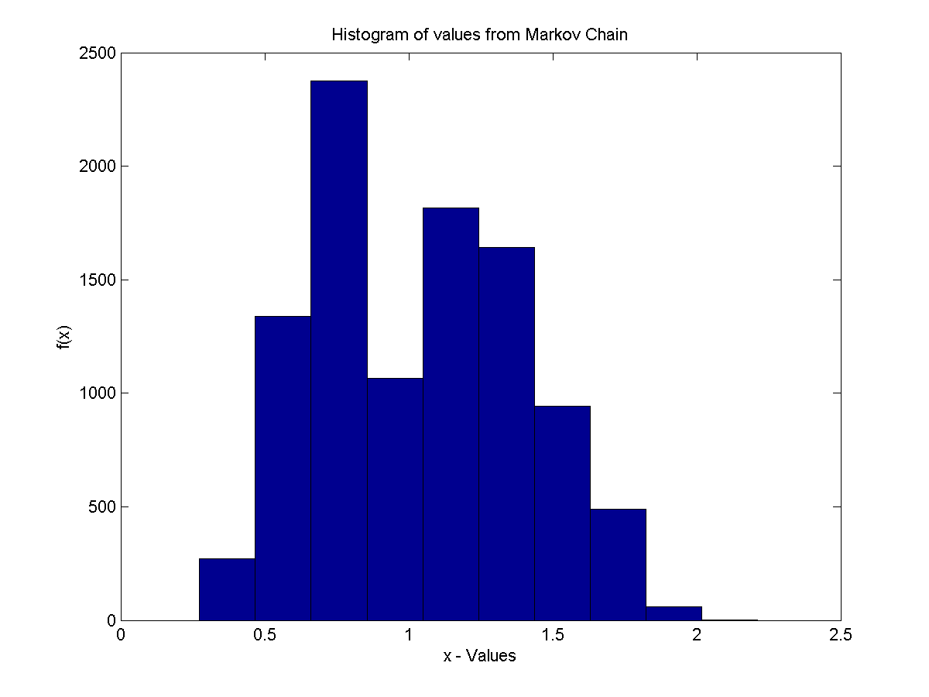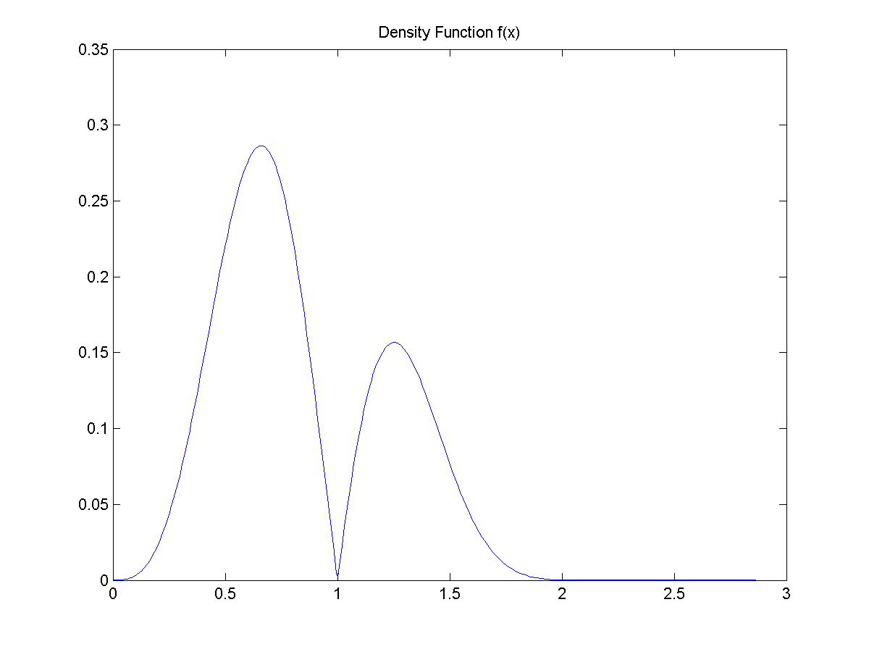

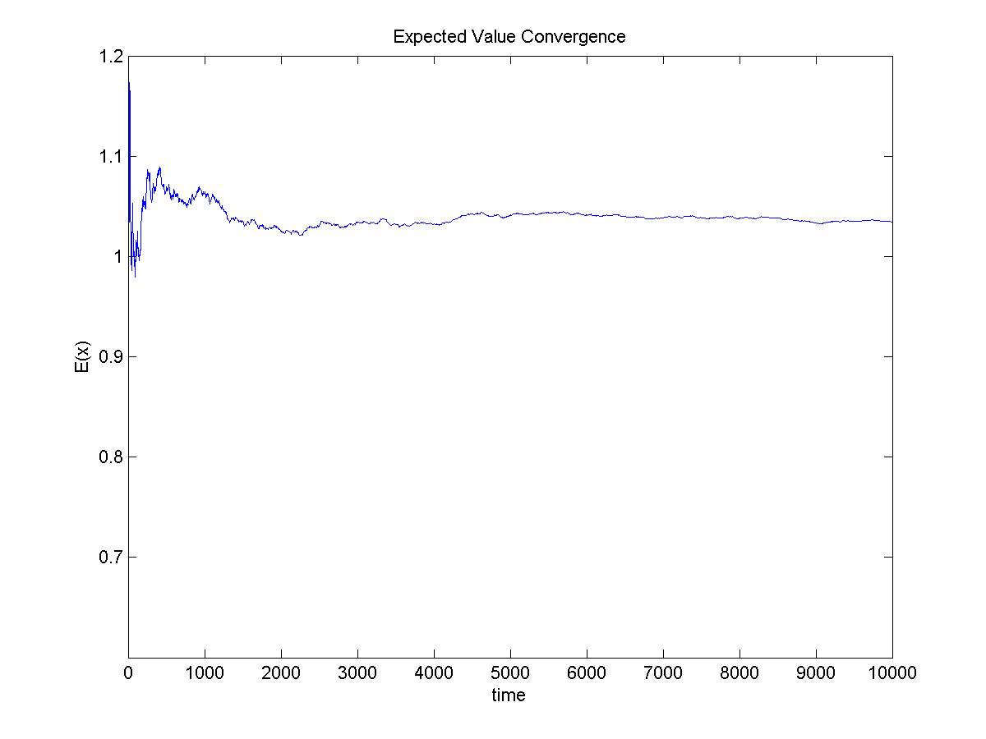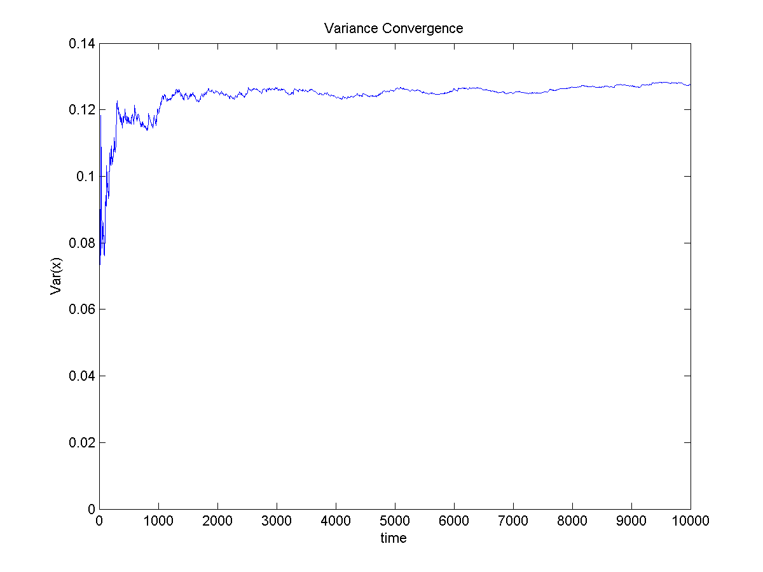

exp_x1 =

1.0190

var_x1 =

0.1315

**CODE**

clear all

clc

alpha=3;

beta=0.8;

x = -log(rand);

for i=1:10000;

y = -1*beta*log(rand);

u1 = rand;

fun1 = fun4_prob1(x,y,alpha,beta);

if u1 <=fun1

x=y;

else

x=x;

end;

x_1(i)=x;

exp_x(i) = mean(x_1);

var_x(i) = var(x_1);

end;

figure(1)

hist(x_1);

xlabel('x - Values')

ylabel('f(x)')

title(['Histogram of values from Markov Chain']);

saveas(figure(1),['Histogram MC-Values prob1.png'])

exp_x1 = mean(x_1)

var_x1 = var(x_1)

figure(2)

func=@(x) x*x*abs(sin(pi*x))*exp(-abs(x)^3);

fplot(func,[0,3]);

title(['Density Function f(x)']);

saveas(figure(2),['Density Function prob1.png'])

figure(3)

plot(exp_x)

xlabel('time')

ylabel('E(x)')

title(['Expected Value Convergence']);

saveas(figure(3),['Expected Convergence prob1.png'])

figure(4)

plot(var_x)

xlabel('time')

ylabel('Var(x)')

title(['Variance Convergence']);

saveas(figure(4),['Variance Convergence prob1.png'])

2.

**OUTPUT**

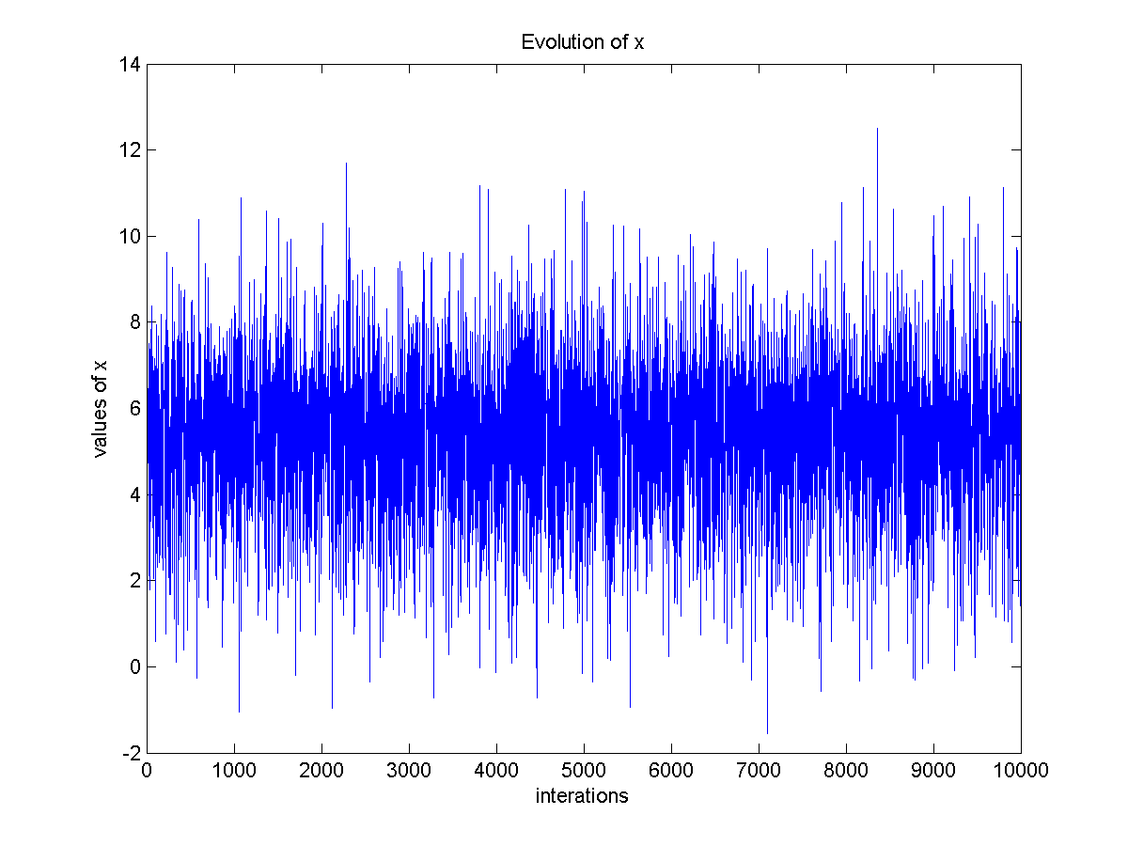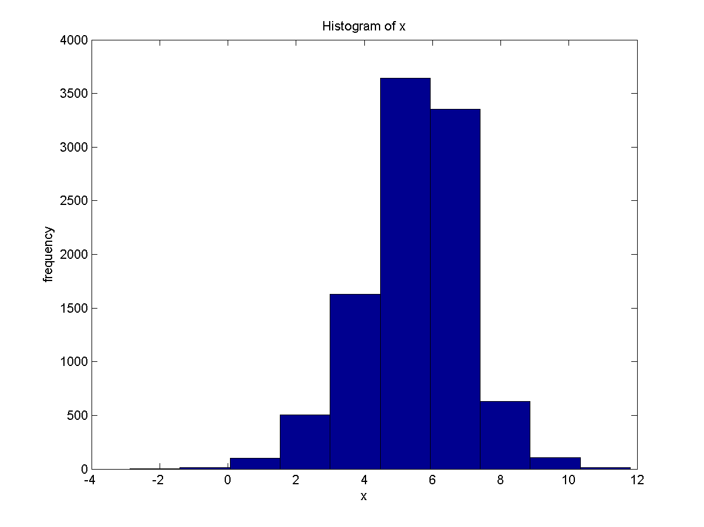

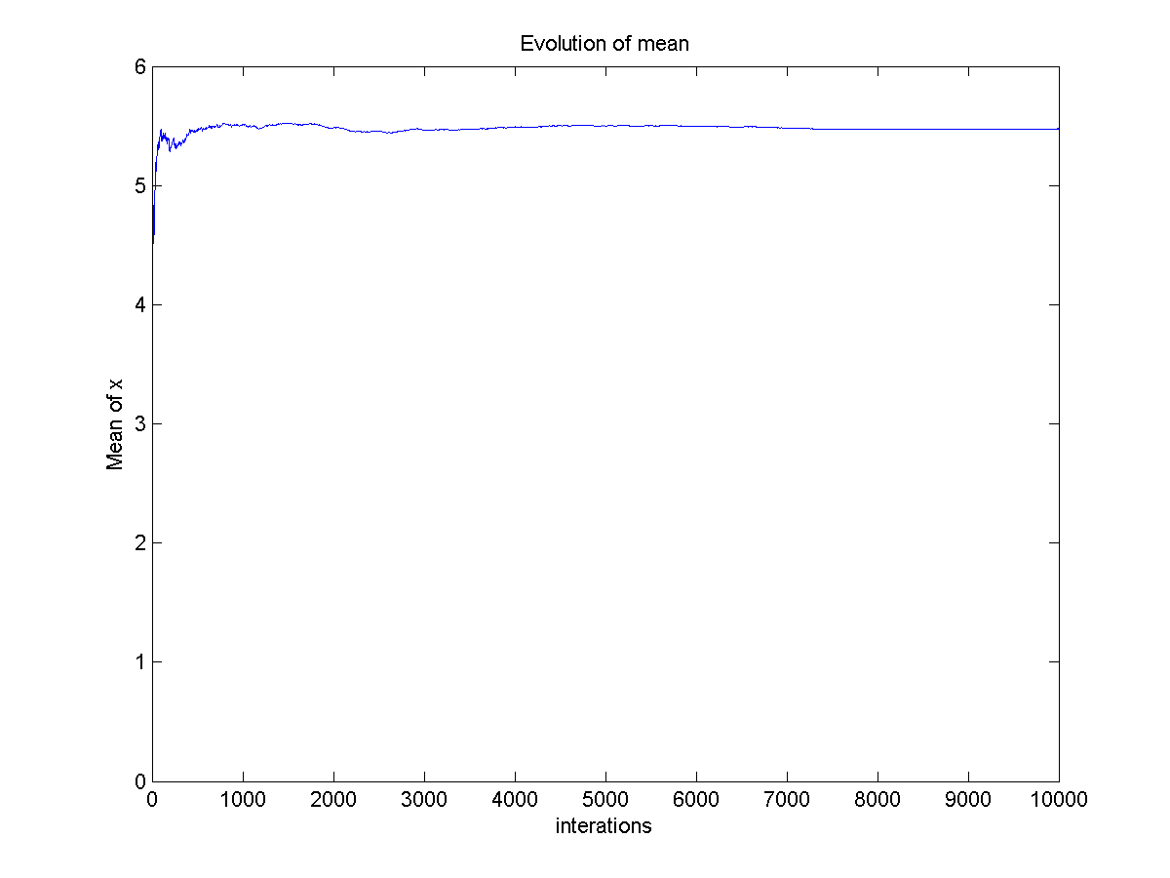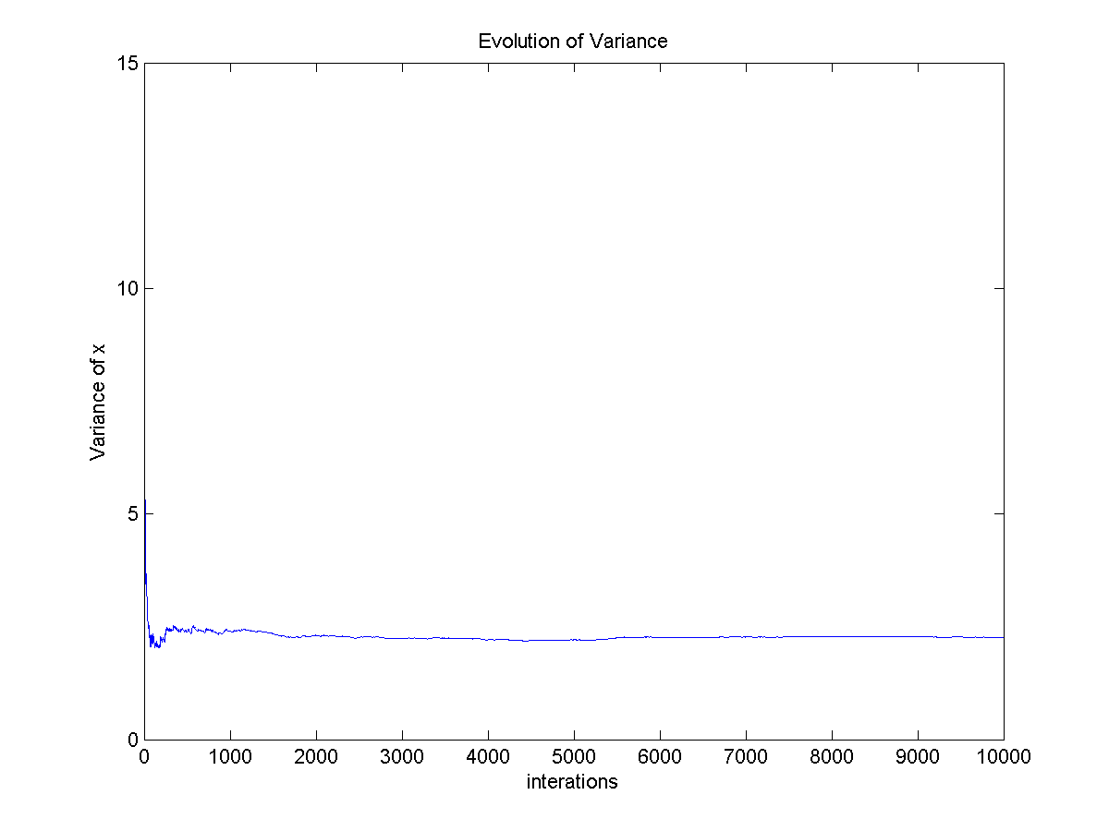

b)

Estimated posterior mean:

ans =

5.4758

Estimated posterior variance

ans =

2.2685

**CODE**

clear all

clc

n=10000;

x = zeros(1,n);

x(1) = rand;

for i=2:n

u1= rand;

z=random('normal',5,2);

if u1<=fun1_prob2(x(i-1),z);

x(i)=z;

else

x(i)=x(i-1);

end;

mean1(i) = mean(x(1:i));

var1(i) =var(x(1:i));

end

mean1(n)

var1(n)

figure(1)

hist(x);

xlabel('x');

ylabel('frequency');

title(['Histogram of x']);

saveas(figure(2),['Histogram of x prob2.png'])

figure(2)

plot(x);

xlabel('interations');

ylabel('values of x');

title(['Evolution of x']);

saveas(figure(2),['Values of x prob2.png'])

figure(3)

plot(mean1);

xlabel('interations');

ylabel('Mean of x');

title(['Evolution of mean']);

saveas(figure(3),['Evolution of mean prob2.png'])

figure(4)

plot(var1);

xlabel('interations');

ylabel('Variance of x');

title(['Evolution of Variance']);

saveas(figure(4),['Evolution of Variance prob2.png'])

3.

**OUTPUT** Checkboard

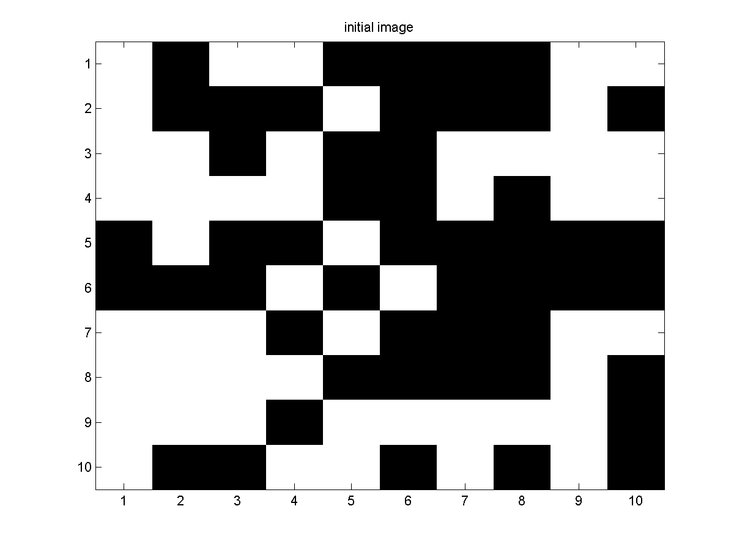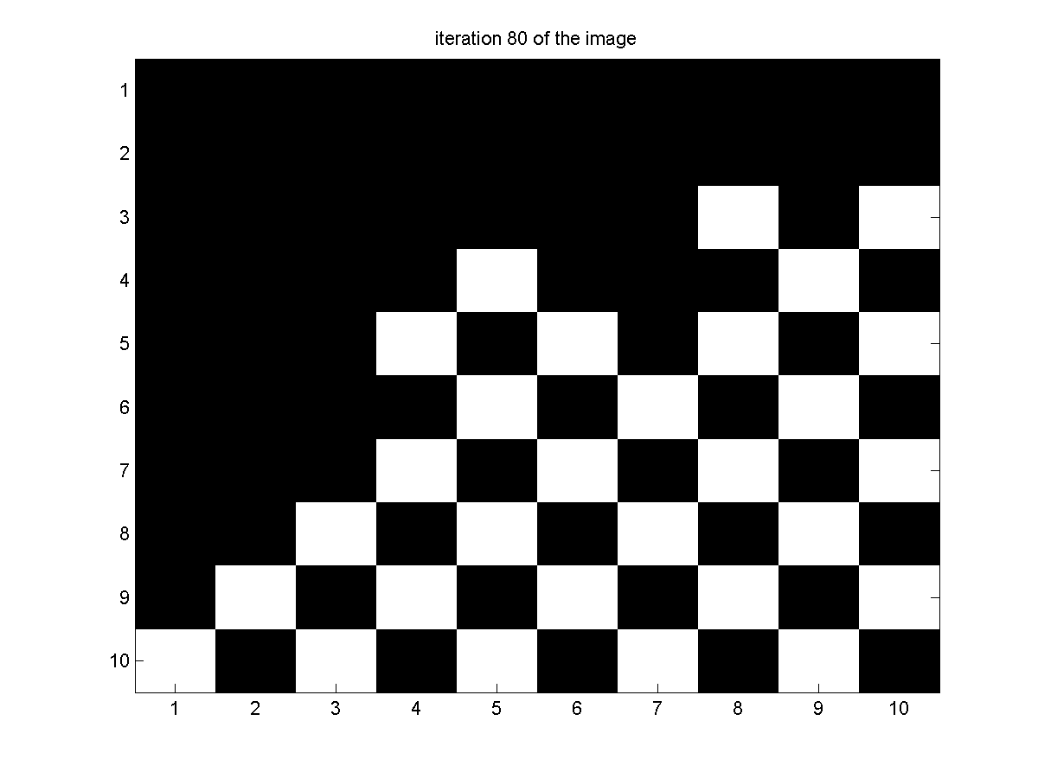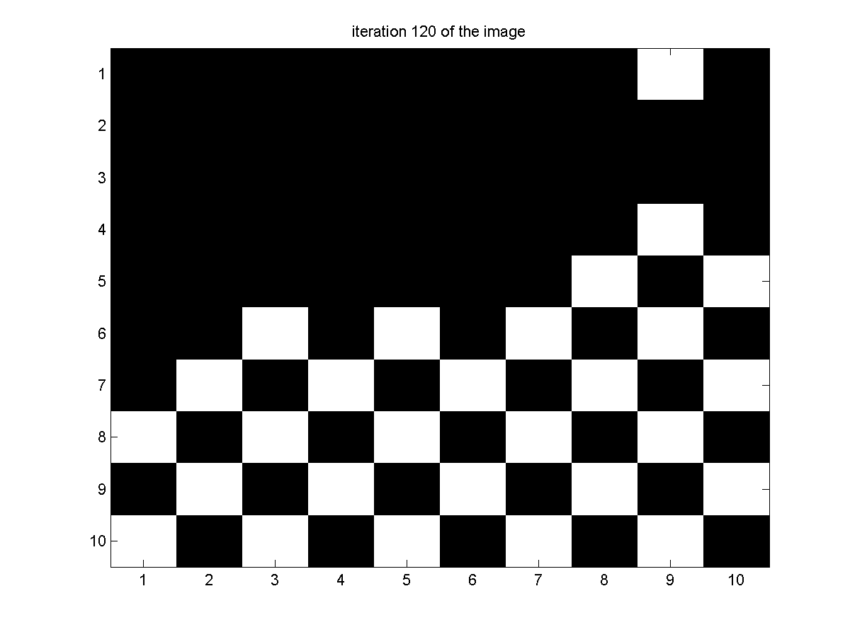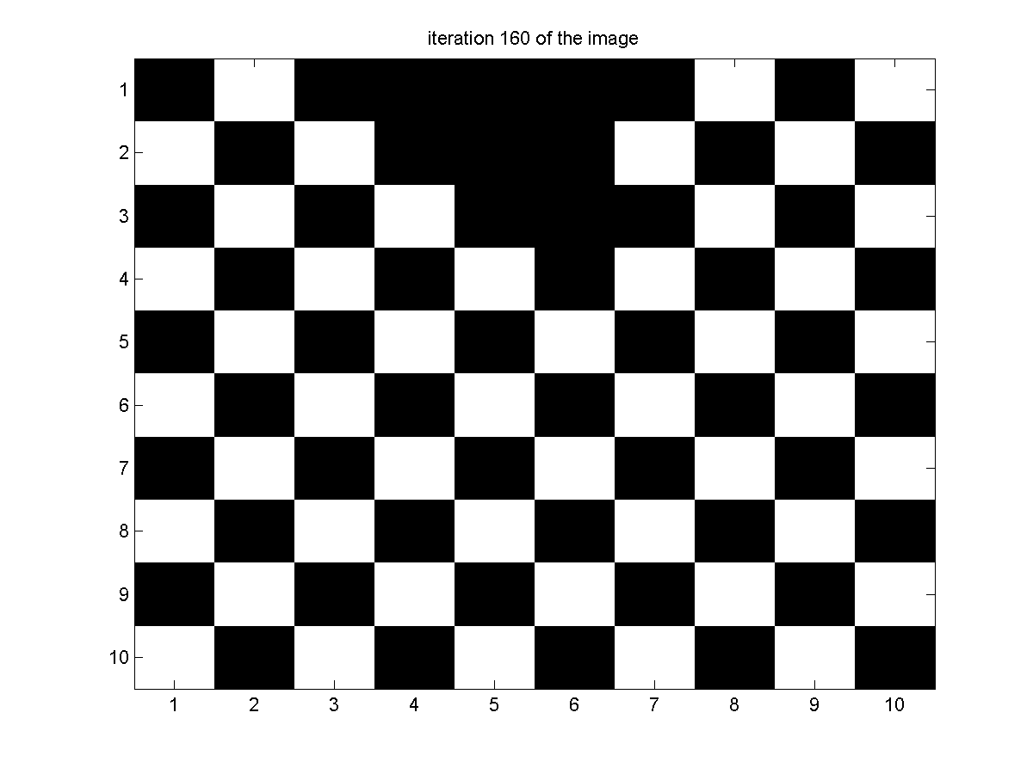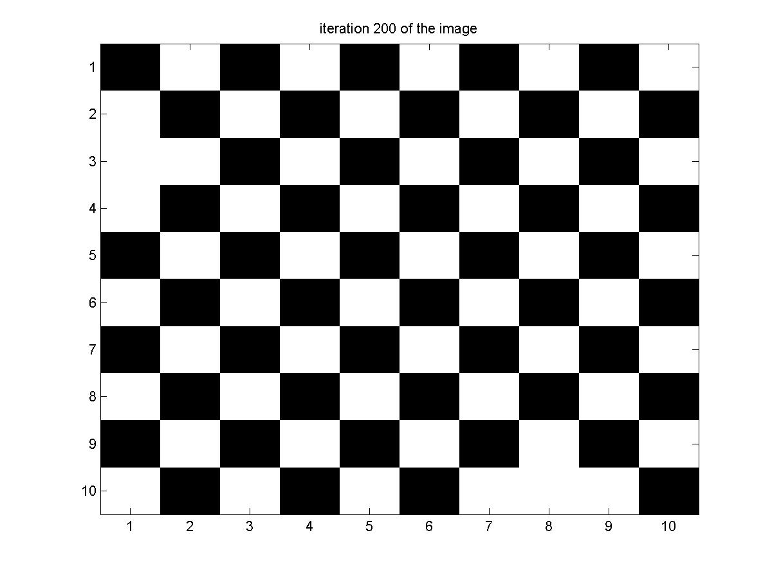

Black Board

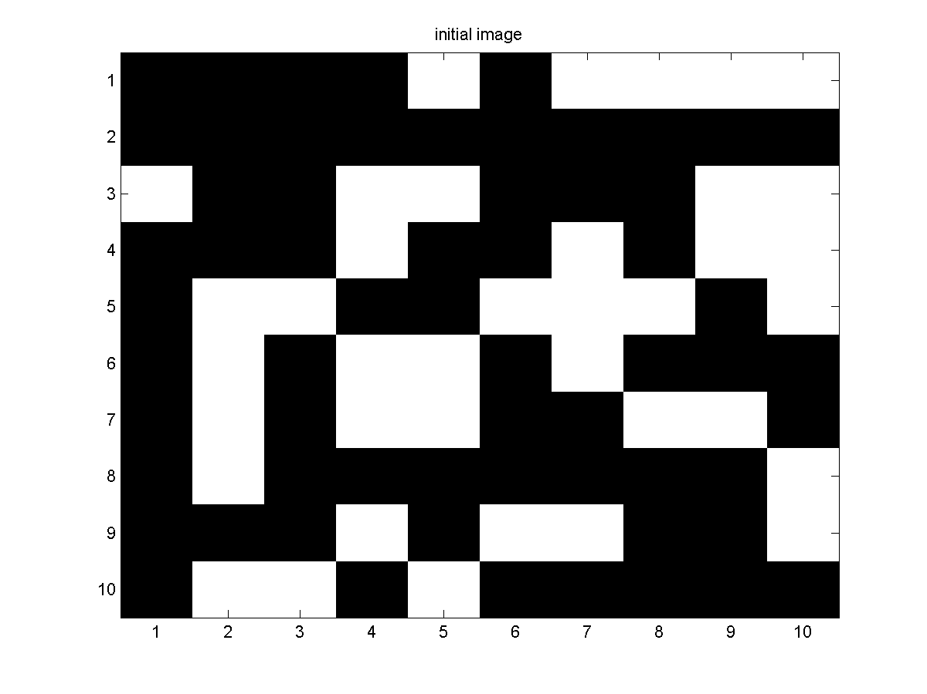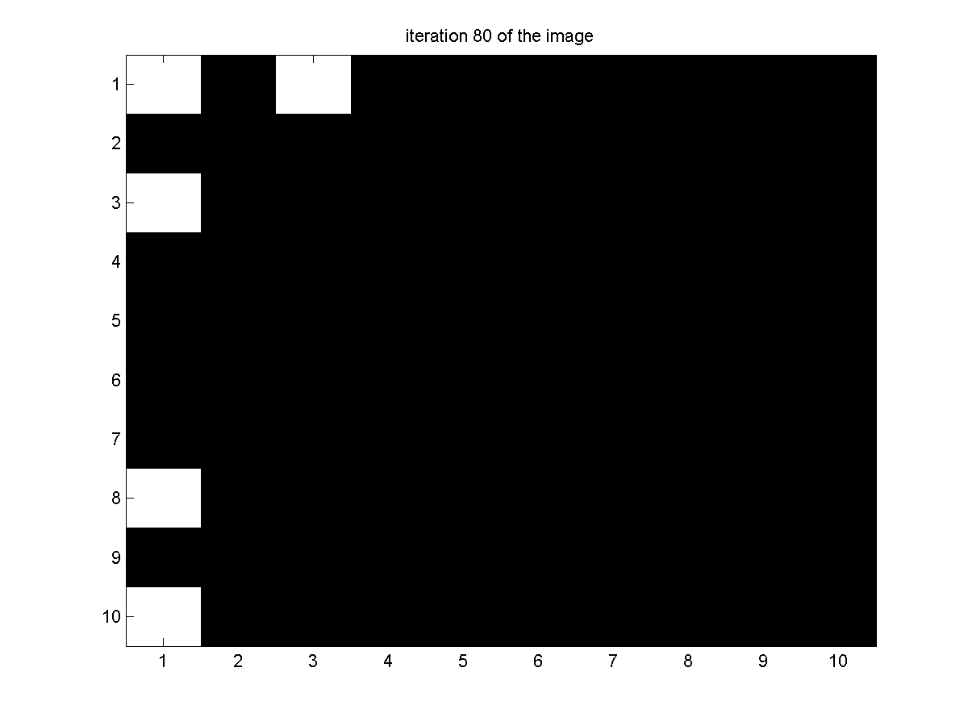

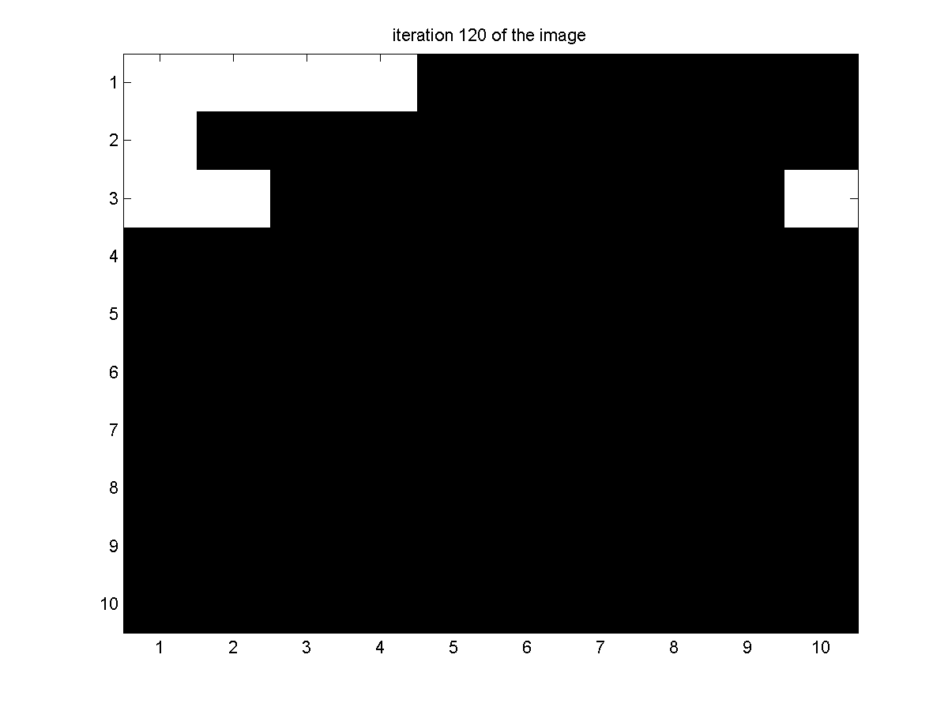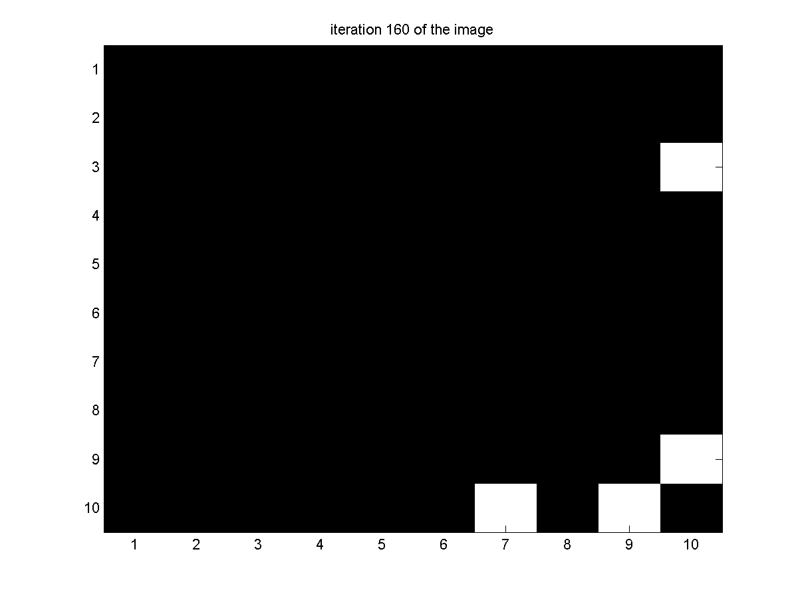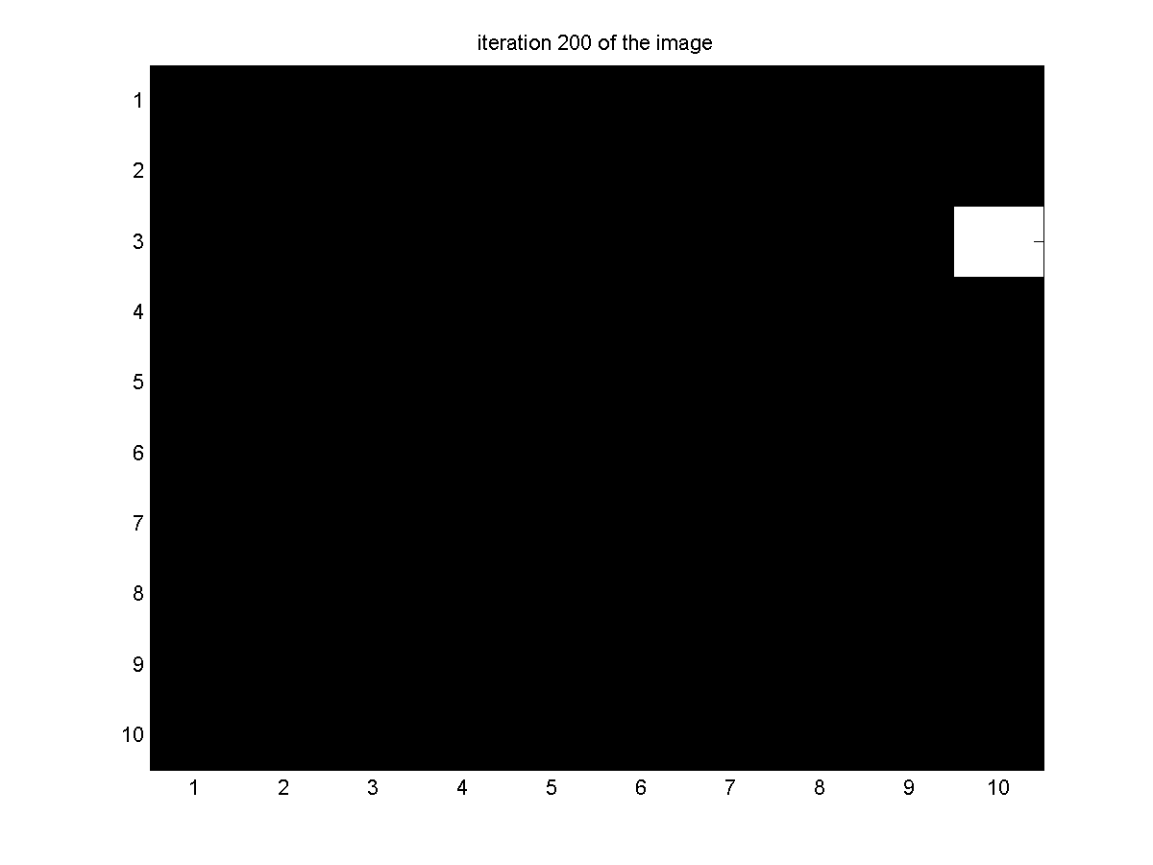

White board

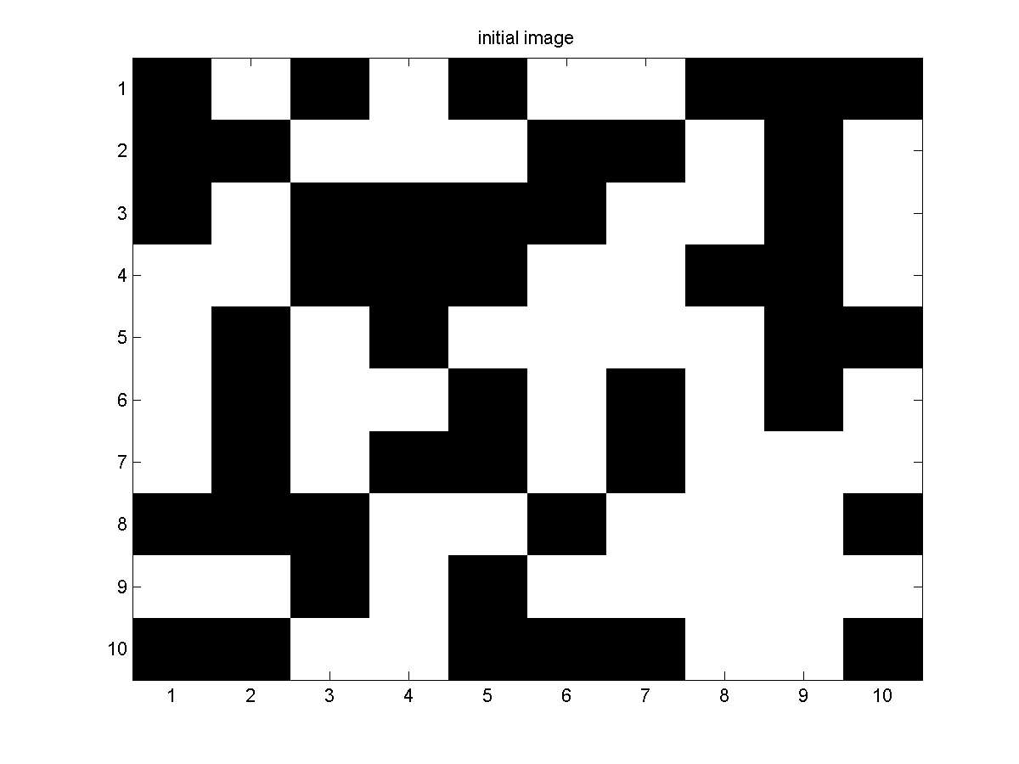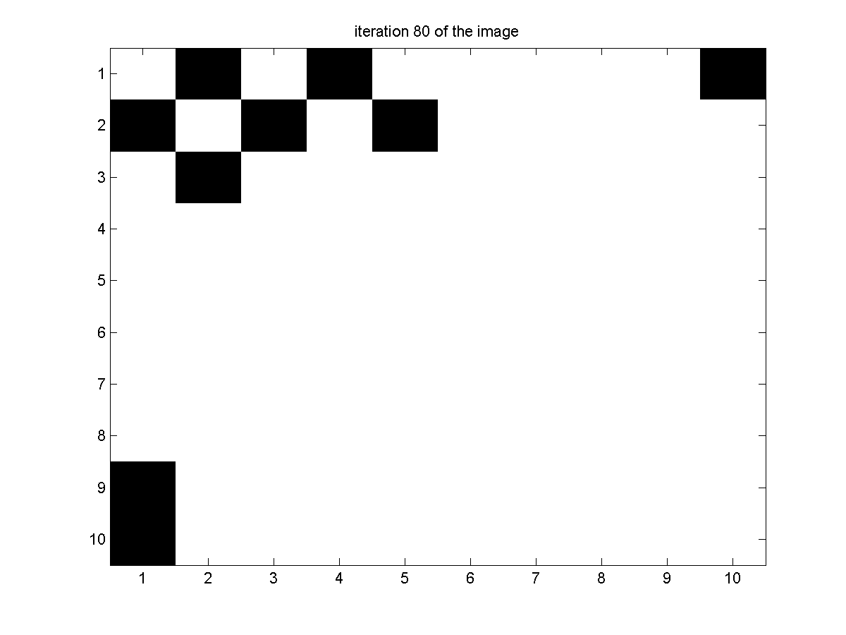

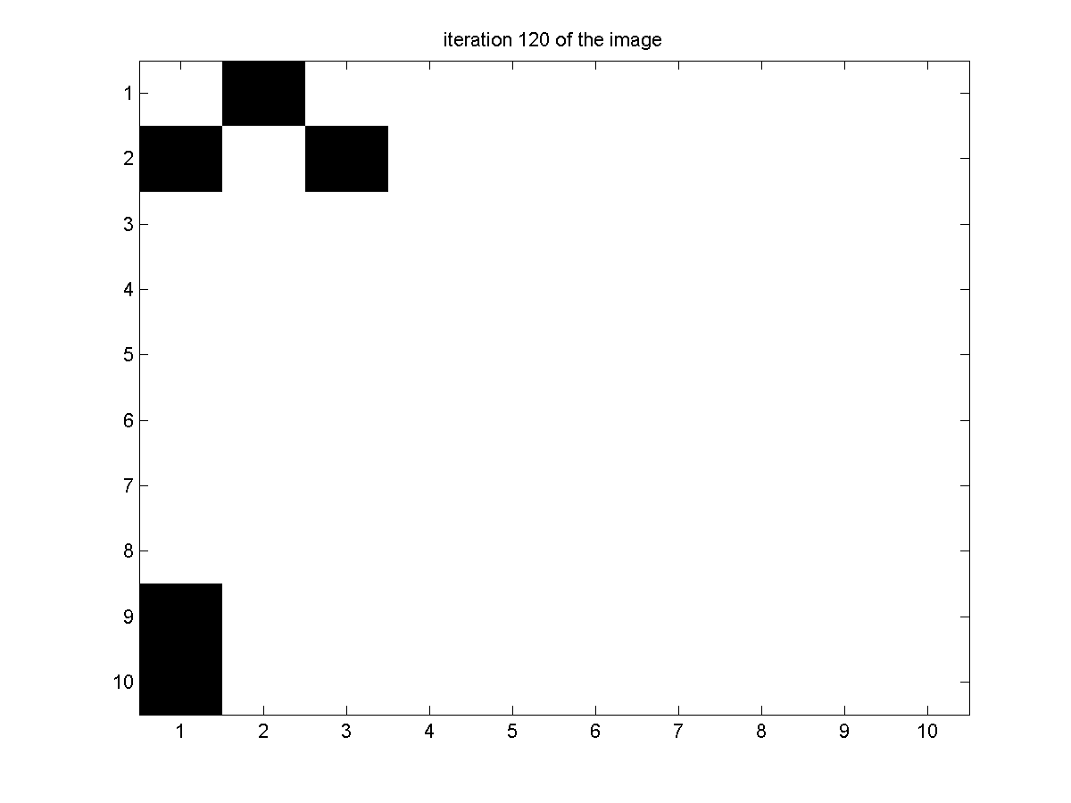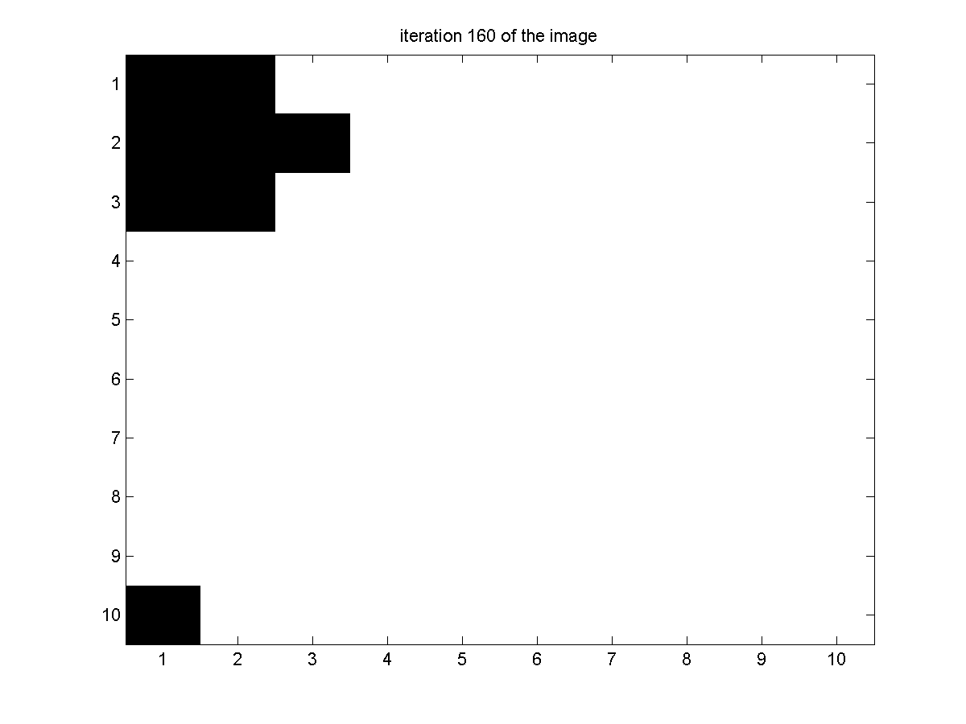

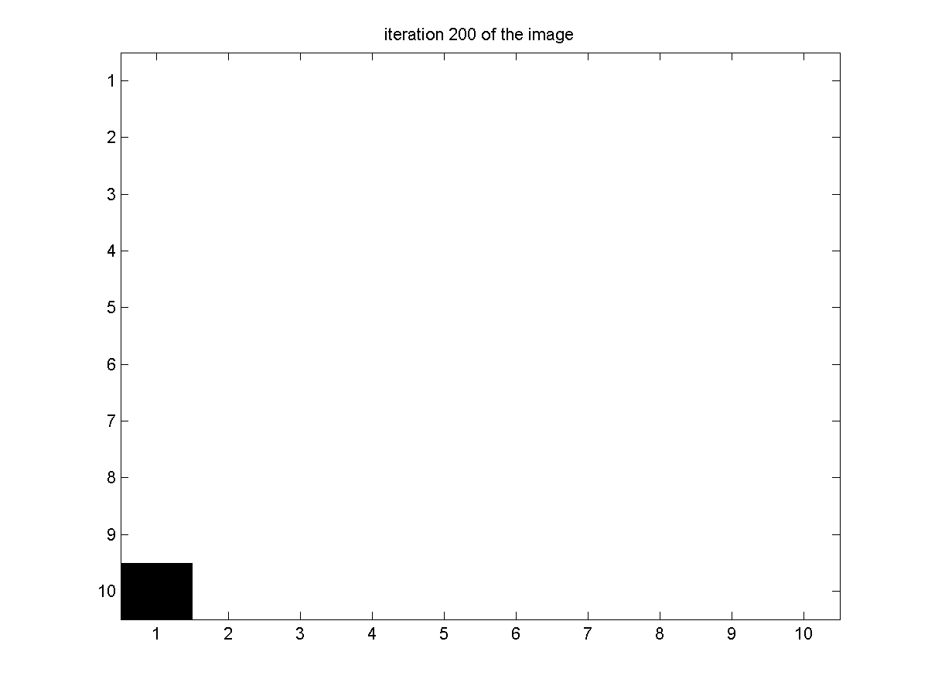

**CODE**

clear all

clc

n=12;

x=rand(n,n,1);

for j=1:n;

for k=1:n

if x(j,k,1)<=0.5

x(j,k,1) = -1;

else

x(j,k,1) = 1;

end;

end;

end;

figure(1)

imagesc(x(2:n-1,2:n-1,1));

colormap('gray');

title('initial image');

saveas(figure(1),['Initial Image prob3.png']);

n1=200;

for i=2:n1;

x(:,:,i)= x(:,:,i-1);

for j=2:n-1;

for k=2:n-1

alpha1=x(j+1,k,i-1) + x(j-1,k,i-1)+x(j,k+1,i-1)+x(j,k-1,i-1);

p=exp(-x(j,k,i-1)*alpha1)/(exp(alpha1)+exp(-alpha1));

if p<=rand;

x(j,k,i)=x(j,k,i-1);

else

x(j,k,i)=-x(j,k,i-1);

end

end;

end

end;

figure(2)

imagesc(x(2:n-1,2:n-1,(floor(n1/5))*2));

colormap('gray');

title(['iteration ' int2str(floor(n1/5)*2) ' of the image']);

saveas(figure(2),['iteration ' int2str(floor(n1/5)*2) ' prob3.png']);

figure(3)

imagesc(x(2:n-1,2:n-1,floor(n1/5)*3));

colormap('gray');

title(['iteration ' int2str(floor(n1/5)*3) ' of the image']);

saveas(figure(3),['iteration ' int2str(floor(n1/5)*3) ' prob3.png']);

figure(4)

imagesc(x(2:n-1,2:n-1,floor(n1/5)*4));

colormap('gray');

title(['iteration ' int2str(floor(n1/5)*4) ' of the image']);

saveas(figure(4),['iteration ' int2str(floor(n1/5)*4) ' prob3.png']);

figure(5)

imagesc(x(2:n-1,2:n-1,floor(n1/5)*5));

colormap('gray');

title(['iteration ' int2str(floor(n1/5)*5) ' of the image']);

saveas(figure(5),['iteration ' int2str(floor(n1/5)*5) ' prob3.png']);

4.

**OUTPUT**

I1.txt

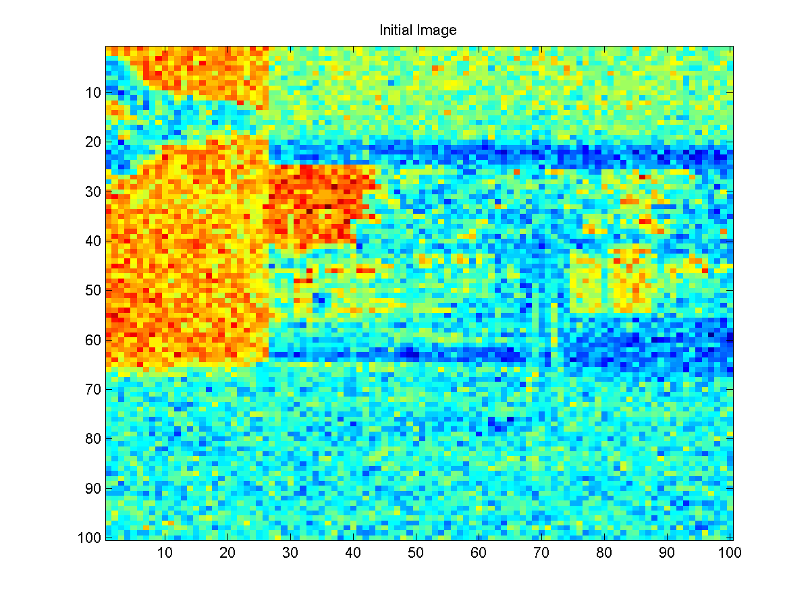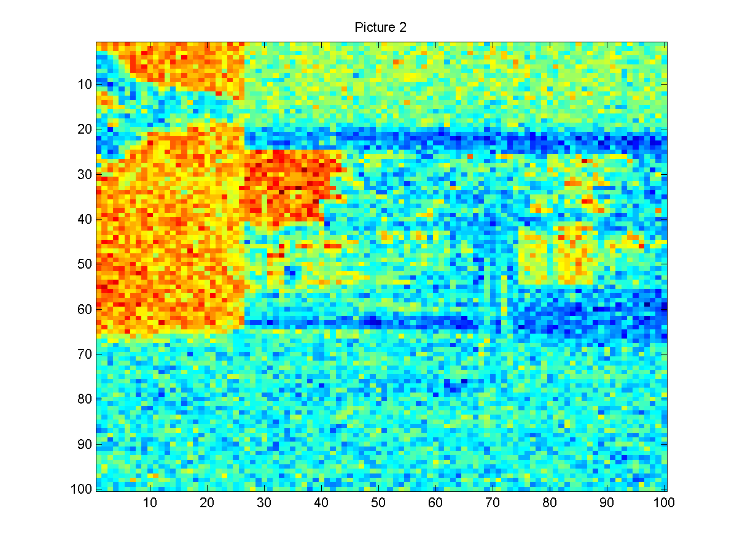

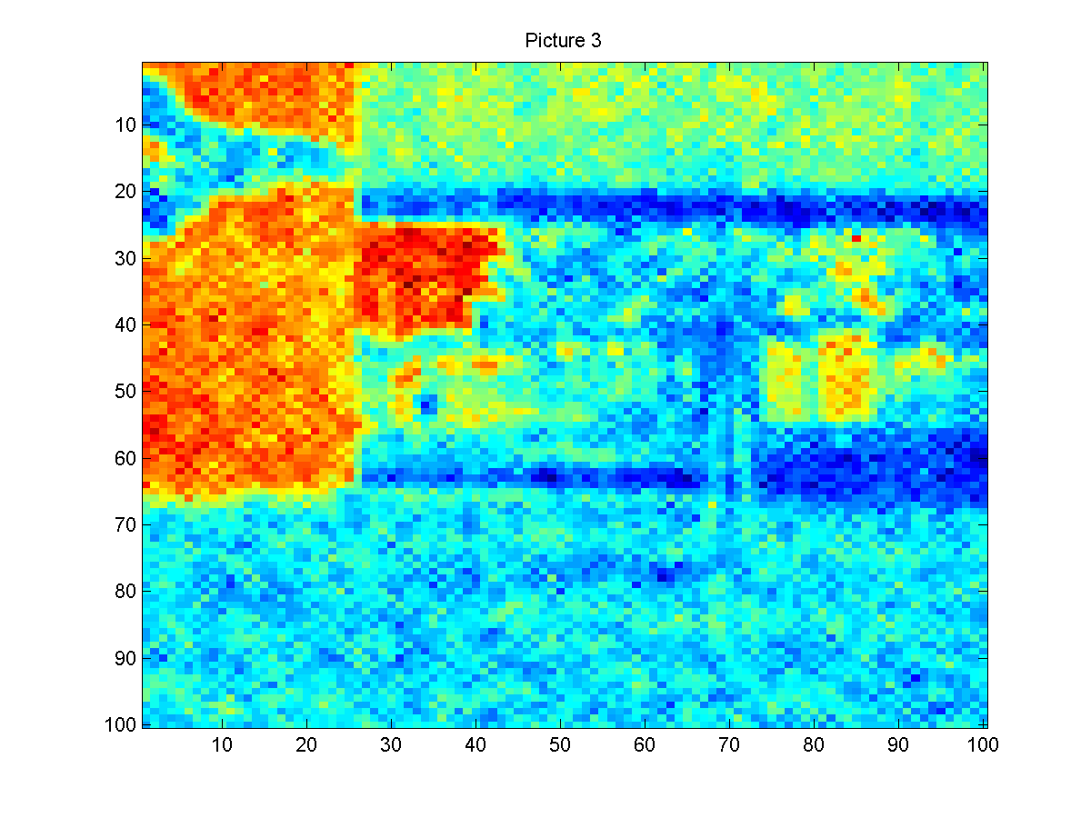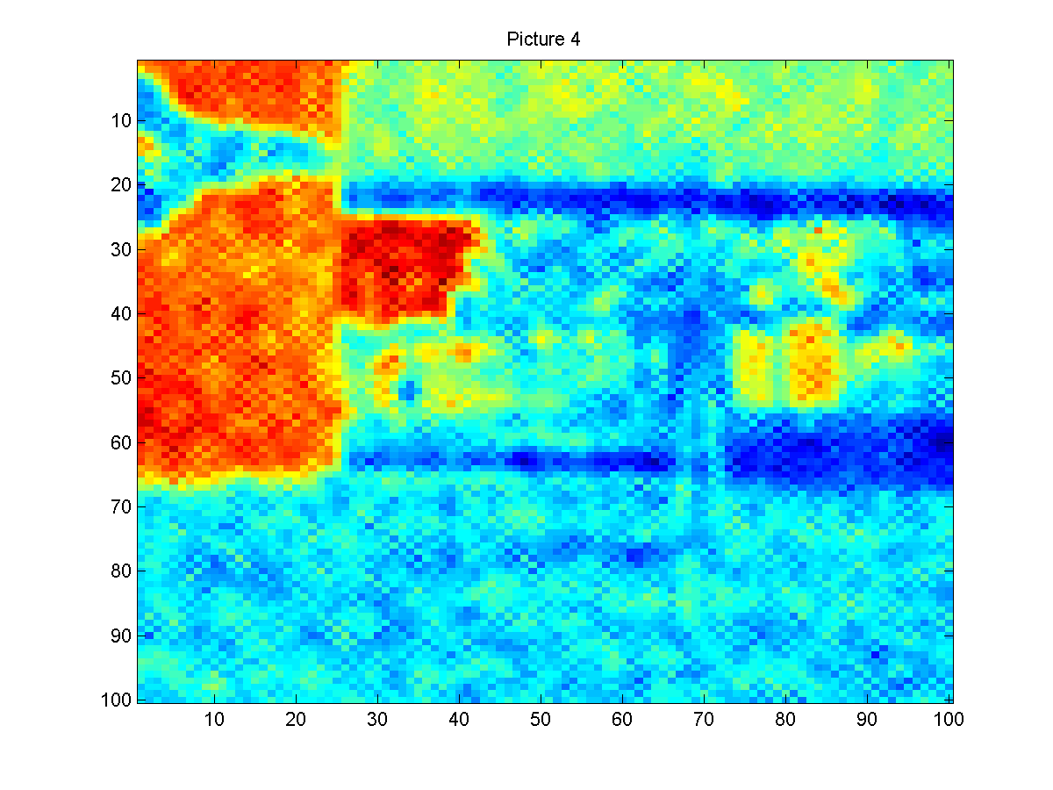

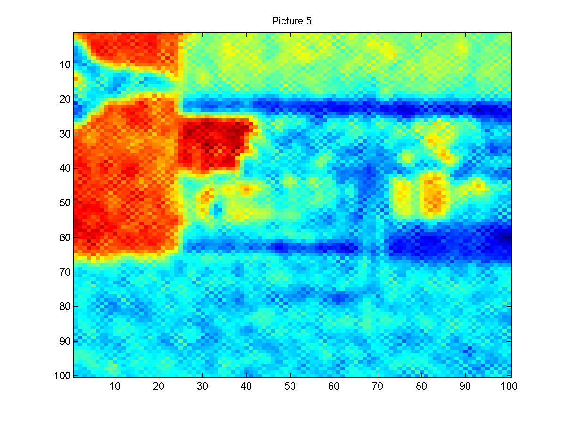

I2.txt

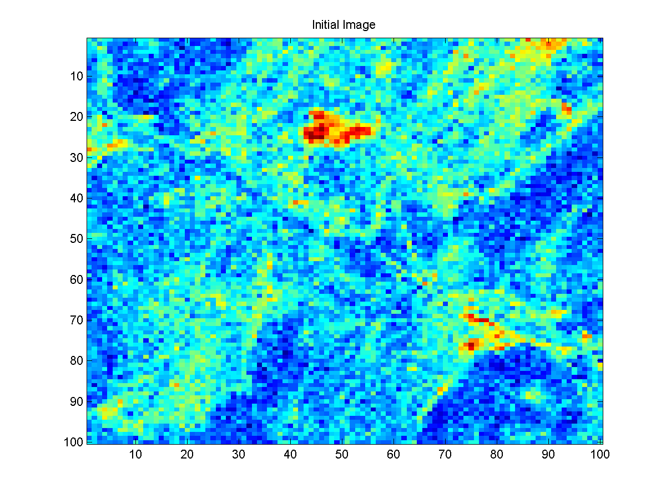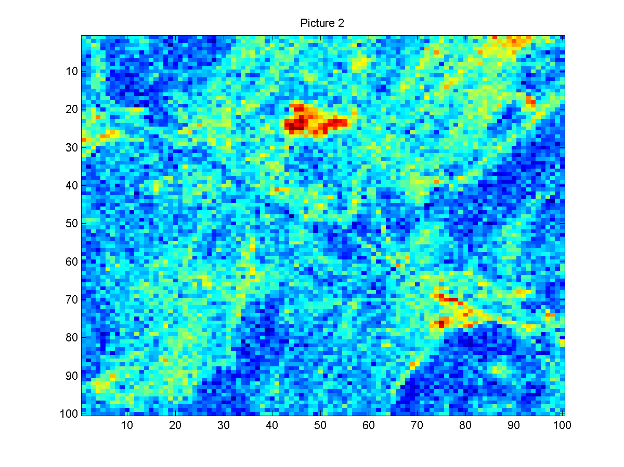

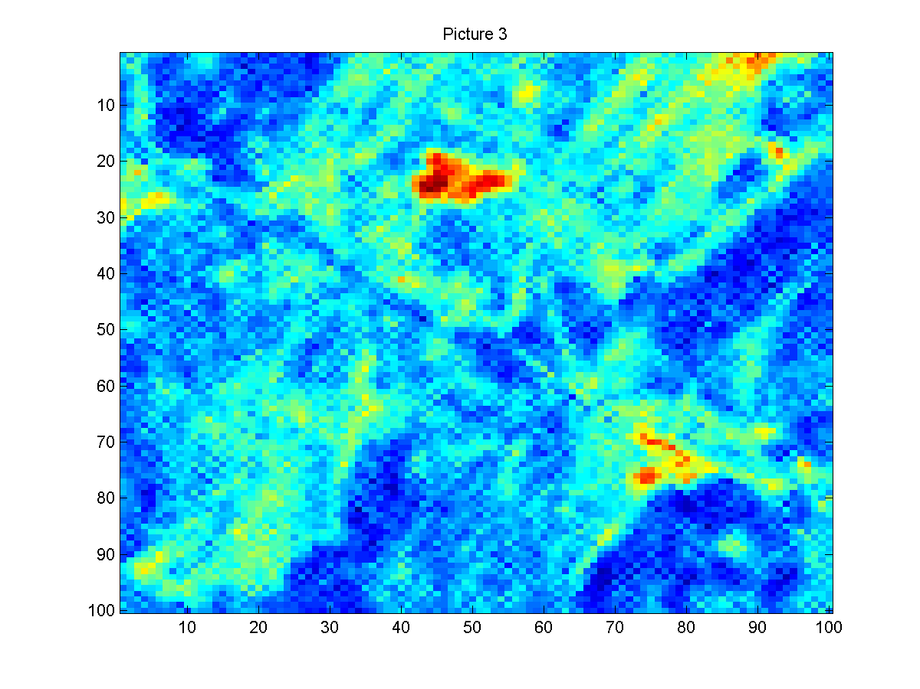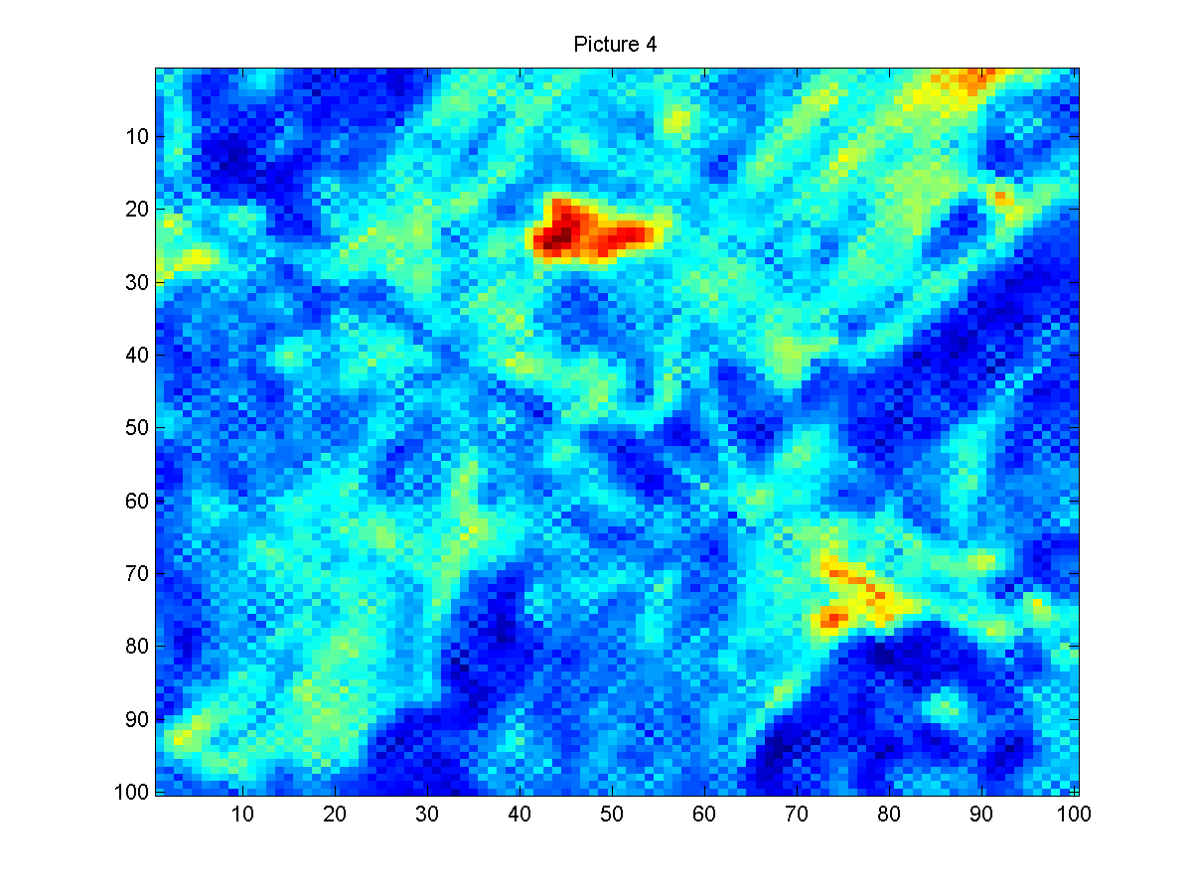

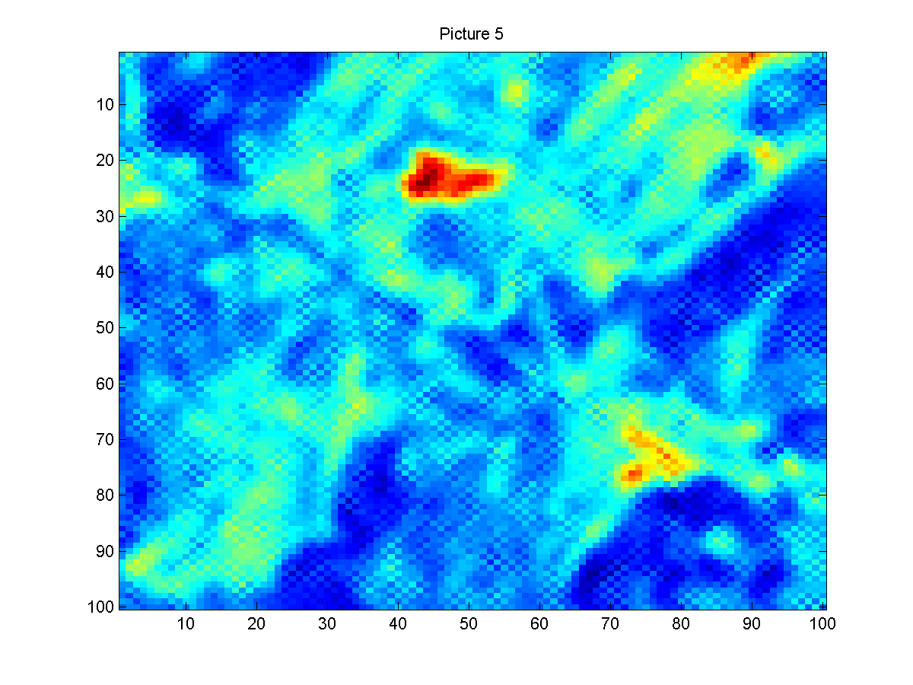

I3.txt

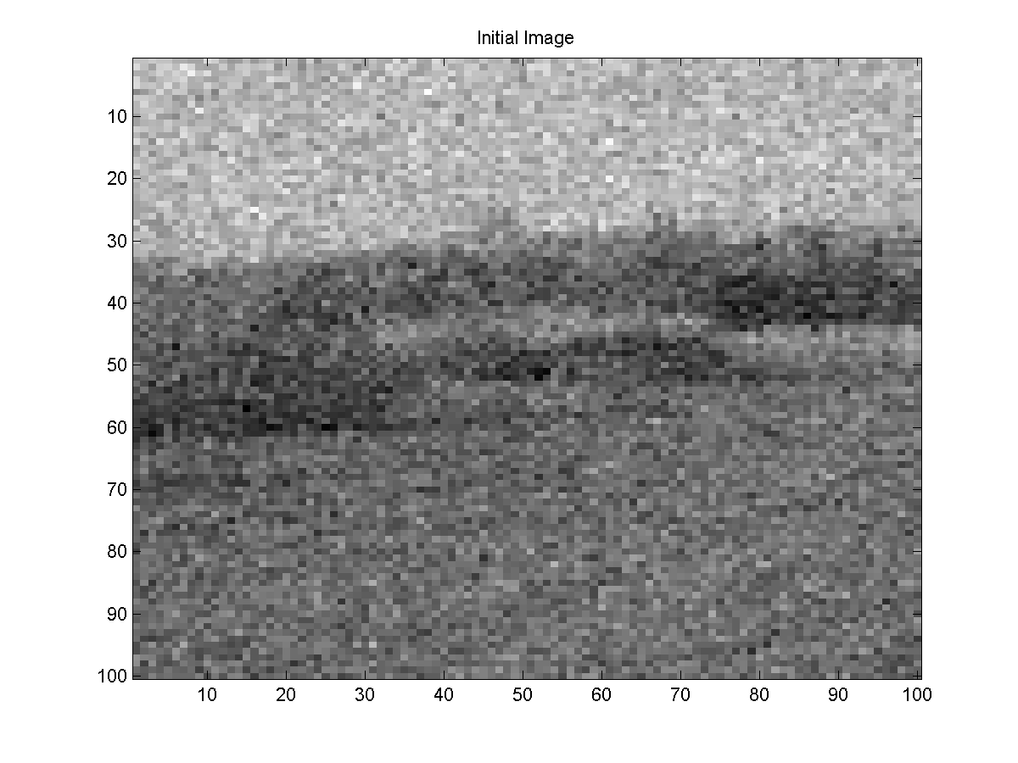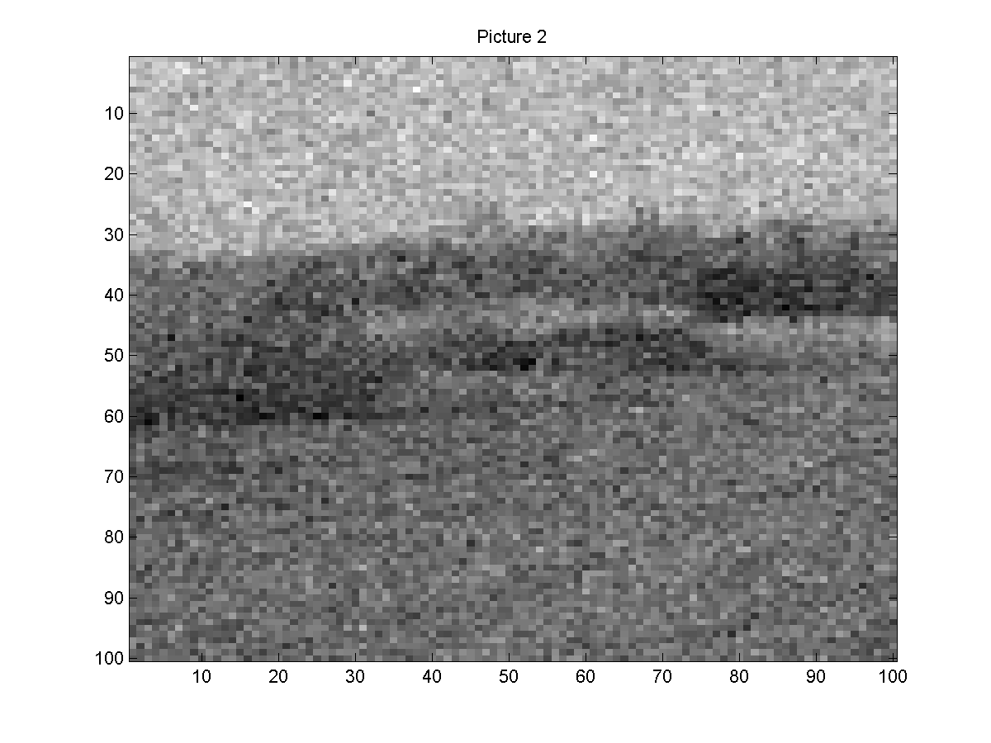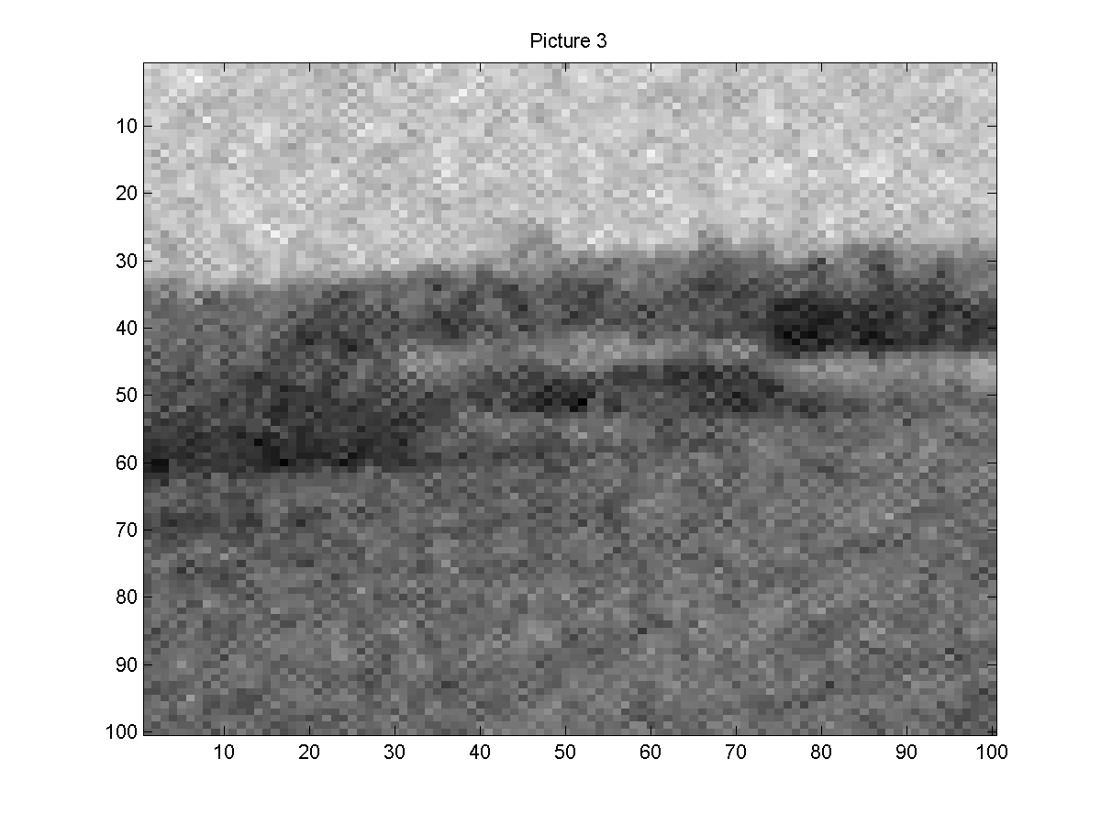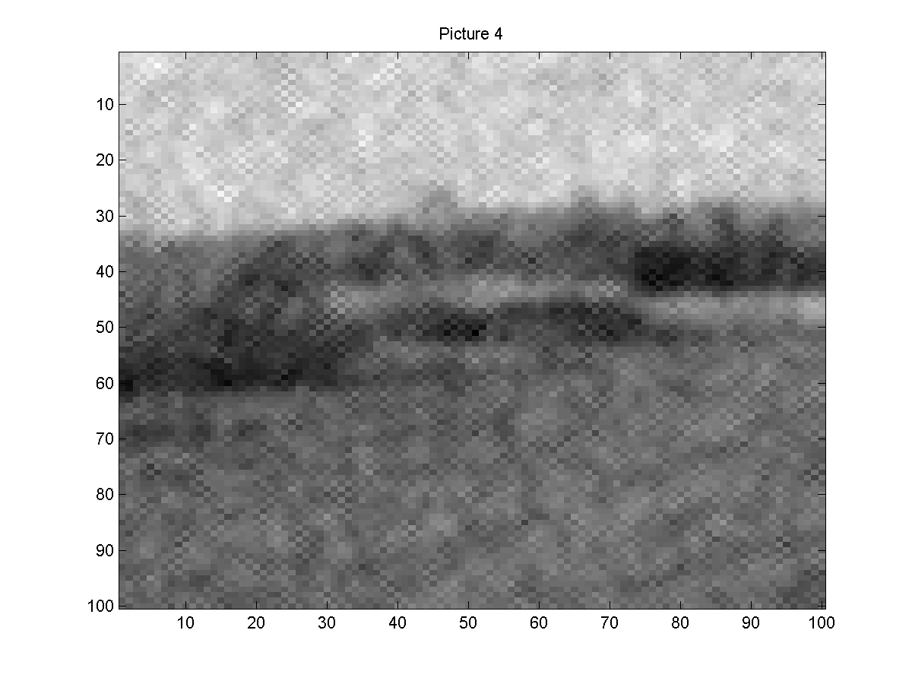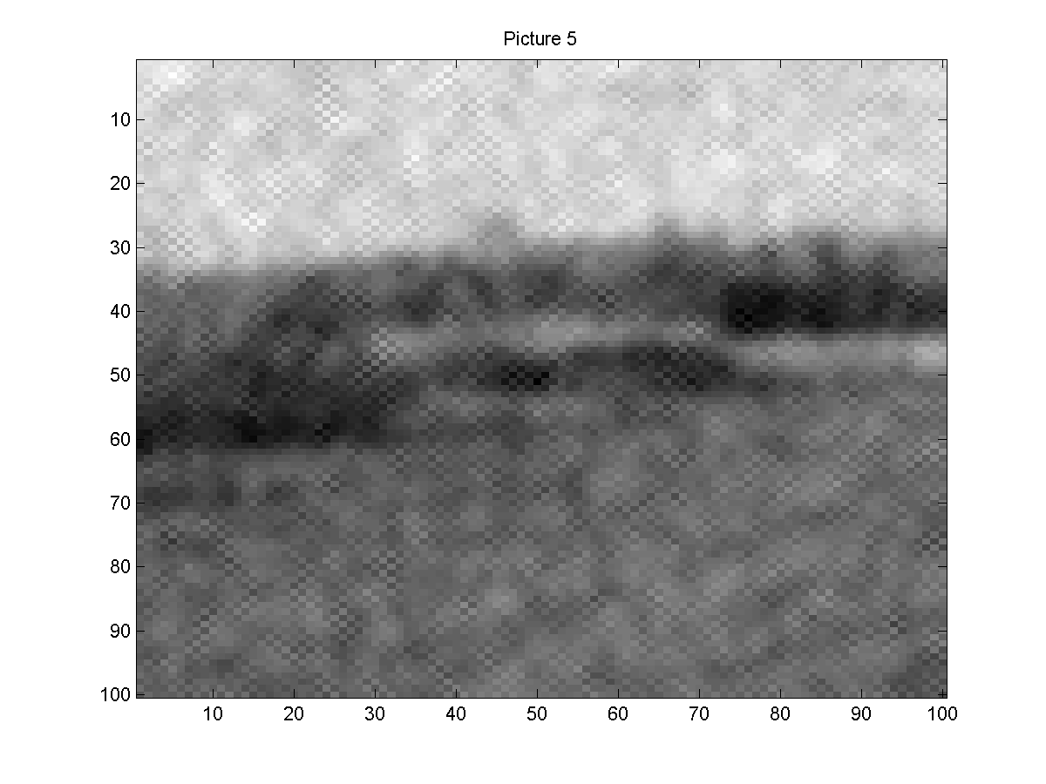

I4.txt

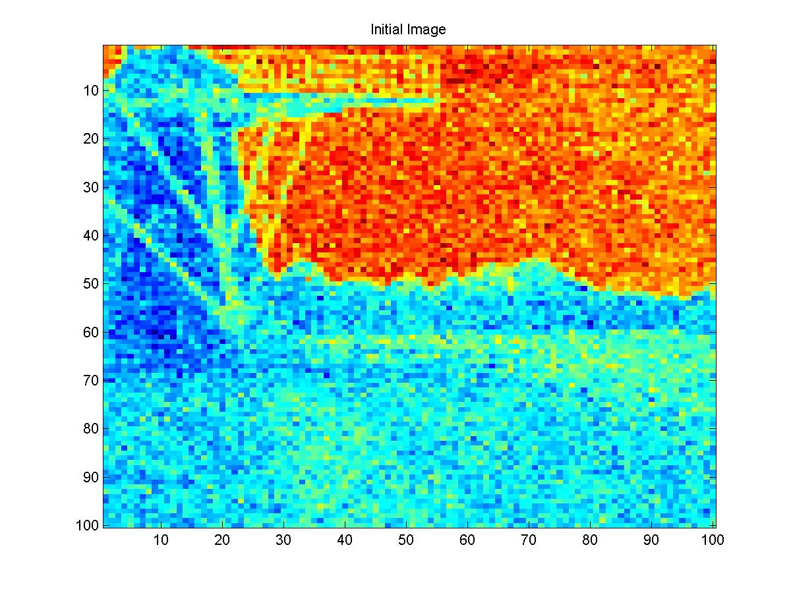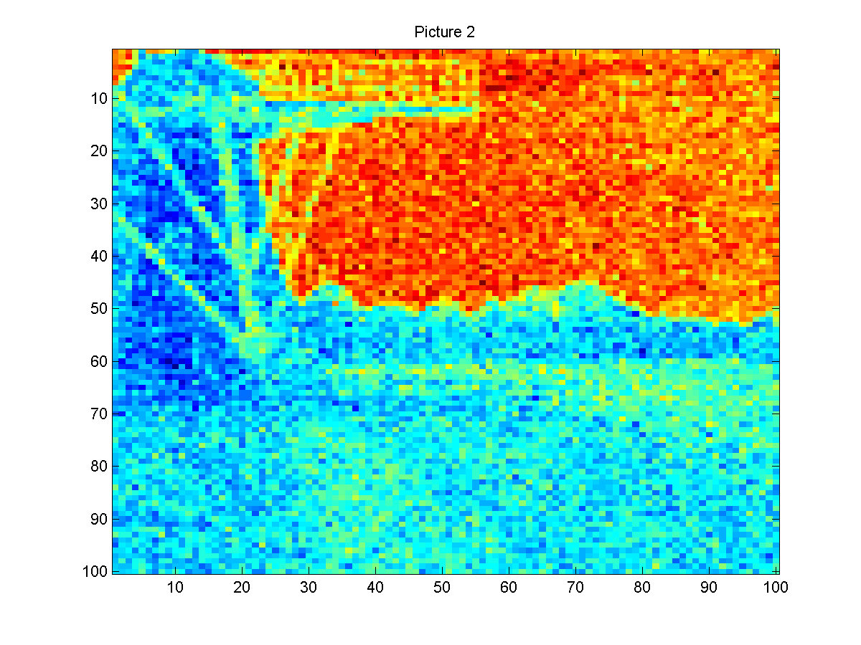

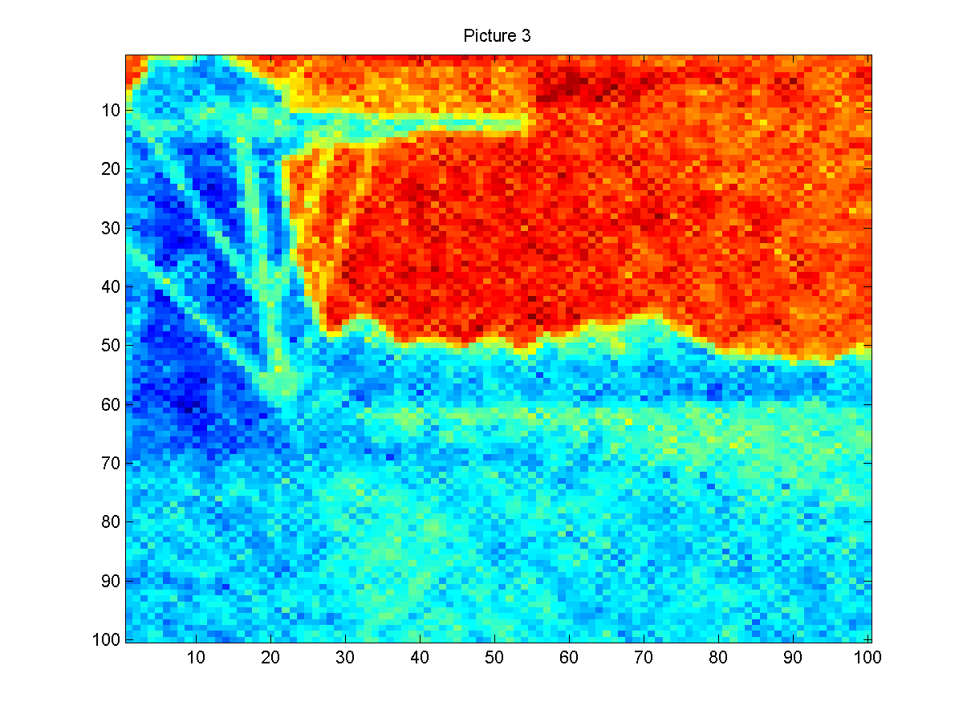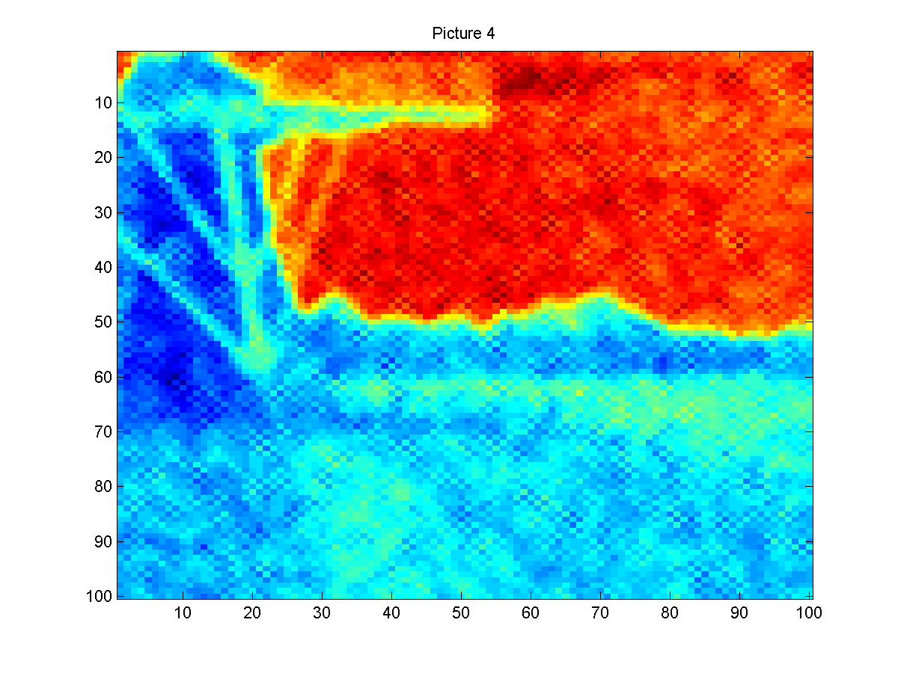

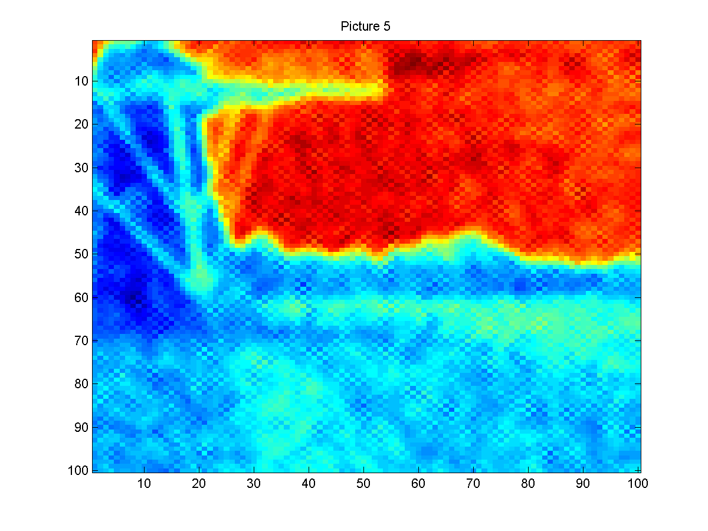

**CODE**

clear all

clc

load('I4.txt');

x(:,:,1)=I4;

[n1,n1]=size(I4);

loop=5;

figure(1)

imagesc(x(:,:,1));

title('Initial Image');

saveas(figure(1),['Initial Image prob4-4.png']);

for i=2:loop;

x(:,:,i)= x(:,:,i-1);

for j=1:n1;

for k=1:n1;

[n2,n2,n3]=size(x);

if (j==1) && (k==1)

mid=(x(j,k+1,i-1)+x(j+1,k,i-1))/2;

end;

if (j==1) && (k==n2)

mid=(x(1,k-1,i-1)+x(j+1,k,i-1))/2;

end;

if (j==n2) && (k==1)

mid=(x(j-1,k,i-1)+x(j,k+1,i-1))/2;

end;

if (j==n2) && (k==n2)

mid=(x(j,k-1,i-1)+x(j-1,k,i-1))/2;

end;

if (j==1 && k~=1 && k~=n2)

mid=(x(j+1,k,i-1)+x(j,k-1,i-1)+x(j,k+1,i-1))/3;

end;

if (j==n1 && k~=1 && k~=n2)

mid=(x(j-1,k,i-1)+x(j,k-1,i-1)+x(j,k+1,i-1))/3;

end;

if (j~=1 && j~=n2 && k==1)

mid=(x(j-1,k,i-1)+x(j+1,k,i-1)+x(j,k+1,i-1))/3;

end;

if (j~=1 && j~=n2 && k==n2)

mid=(x(j-1,k,i-1)+x(j+1,k,i-1)+x(j,k-1,i-1))/3;

end;

if (j~=1 && j~=n2) && (k~=1 && k~=n2)

mid=(x(j-1,k,i-1)+x(j+1,k,i-1)+x(j,k+1,i-1)+x(j,k+1,i-1))/4;

end;

norm1=random('normal',mid,sqrt(0.1),1,1);

x(j,k,i)=norm1;

end;

end;

figure(i)

imagesc(x(:,:,i-1));

title(['Picture ' int2str(i)]);

saveas(figure(i),['Picture ' int2str(i) ' prob4-4.png']);

end;